Abstract
This project is the first step to reproduce “Automatic chemical design using a data-driven continuous representation of molecules” paper with a much bigger dataset. The idea is that to convert discrete space of SMILES representation for chemical compounds to a latent continuous space and then convert it back to its original format. In the realm of deep learning, this task can be done by autoencoders. The goal of this conversion is that to utilize the continuous latent representation and propose new chemical compounds. In this project, we use the naive autoencoder applied in the stated paper on a new dataset. Results...

Introduction
Design and evaluation of new drug or chemical compounds is expensive and time consuming and the number of potential candidates are extremely high. The goal is to find and propose novel molecules with specific properties via reliable and accurate computational methods. Recently deep neural networks have been applied for data-driven and precise chemical design. In order to achieve novel molecules one must overcome challenges such as huge search space and discrete nature of the problem.
Autoencoders are powerful tools to convert this discrete search space to a latent continuous and again to a discrete space. Conversion from raw input data to the latent space is performed by encoder, and conversion of this latent space to its natural format is done by decoder. The aim of this unsupervised deep learning method is to generate the input again but perform this task by obtaining salient features and accurate distributions of the input data (rather than just learning an identity matrix and copying the input). There are several advantages with the continuous latent representation of the autoencoder. It allows generating novel chemical compounds by performing basic operations such as decoding a random vector or perturbing a known chemical structure. Moreover, since this latent space is continuous, gradient-based optimization tools can be utilized to explore and search it more effectively and efficiently. The input of this problem is The Simplified Molecular-Input Line-Entry System (SMILES) representation of 5.5 million drug-like chemical compounds. As stated above this input space is converted to a continuous latent space which itself is decoded to SMILES output again. The whole process is presented in figure 1.
The goal of this project is to implement the first step of the process of automatic chemical design which is implementation of a naive autoencoder.
The rest of this review organize as follows: first a brief description of naive autoencoder is presented, second, the main reference of this work is discussed, section three is about implementation of this project and its related details, section four is dedicated to results and the last section concludes the report.
I. Autoencoders
An autoencoder is a neural network that is capable of reproducing its input i.e. whatever x the input of its input layer is, an autoencoder rebuilds that input internally and send it to the output layer. One might deduce that generating the same input is pointless, however, we are not interested in the input itself because what interests scientific community regarding applying this neural network is its hidden layer h that has the capability of reproducing the input. In another words, h describes the code applied to represent x. Each autoencoder has an encoder part which has the encoder function h = f(x) and a decoder part r = g(h) which is responsible for the reconstruction task. The goal is to design an autoencoder that is unable to achieve g(f(x)) = x perfectly everywhere, because such an autoencoder (g(f(x)) = x for each data point) is probably useless and its capacity is allowed to become too great. Usually autoeconders are under complete which means they put constraints on h to have smaller dimension than x. These constraints forces the autoencoder to learn the most salient features of the training data. Like other machine learning methods, autoencoders perform the learning process with a loss function which simply penalize dissimilarities between x and g(f(x)).
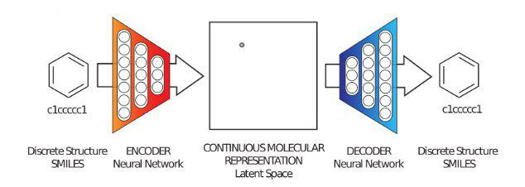

Fig 1. Diagram of the proposed framework for molecular design via auto encoder

Some of more well-known types of autoencoder are as follows: regularized autoencoder, sparse autoencoders, denoising autoencoders, stack autoencoders, variational autoencoders etc. The detailed description of them is beyond the scope of this report. Figure 2 illustrates a basic structure for a naive autoencoder.
II. Automatic chemical design using a data-driven continuous representation of molecules
In this paper, they used two type of autoencoders including naive and variational autoencoders to convert discrete SMILES representation of drug-like molecules and organic light-emitting diodes (OLED) to a latent continuous space and covert it back again to SMILES format. Further they used continuous optimization for mining the generated latent space with the goal of finding new candidate molecules. SMILES representation has a character-by-character nature and fragility in its syntax which can be led to invalid output from the decoder, thus, they trained another model specifically for continuous latent space to predict molecular properties by starting from one point and move in the direction most likely to improve the candidate solution and its related property. The reason that they used two autoencoders is that the naive one led to many dead areas which they do not decode to meaningful molecules. Therefore, another encoder-decoder must be used to solve this issue and ensure that points in the continuous space correspond to valid molecules. Variational autoencoder (VAE) is stochastic in the encoder side and has a penalty term in the decoder one in order to enforce all of the points in the latent space to correspond to a valid decoding. Further, the optimized hyper parameters of VAE such as number of hidden layers, layer sizes, regularization and learning rate by Bayesian optimization. Moreover, they used an outer loop in order to find the optimal value for dimension of the latent space.
III. Implementation
The implementation section of this report can be divided into two sections as follows:
A. Preprocessing and data preparation
The preproccesing of the data has several steps as follows:
The dataset for this project is acquired from in silico drug design lab at Vancouver Prostate Centre which contains almost 5.5 million drug-like molecules in SMILES representation. This dataset was gathered and downloaded from ZINC website. The original data has 6 separate files with some irrelevant columns in .txt format. These 6 files were integrated to one huge one and then shuffled randomly.
After shuffling, this dataset was then padded with spaces in order to make length of the SMILES representations of all of the molecules the same. Since the maximum length in the dataset is 187, all of the other molecules were padded to make them 187 in length.
After padding step, this padded shuffled dataset was divided into three sets including training, validation and test sets. 70% of the data was allocated for training set in order to train the naive autoencoder, 15% was allocated for validation set in order to tune any possible hyper parameters of the
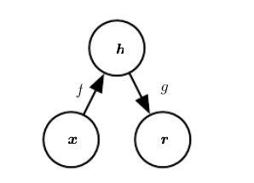

Fig 2. “The general structure of an autoencoder, mapping an input x to an output (called reconstruction) r through an internal representation or code h. The autoencoder has two components: the encoder f (mapping x to h) and the decoder g (mapping h to r)”

implemented autoencoder and finally the remaining 15% was allocated for the test set in order to evaluate the performance of the model for new unseen data.

B. Naive autoencoder

IV. Results and experiments

V. Conclusion

Reference

